WORK

WAGE

PROGRAM

-KASHYAP BINU

-KUSHAL B GOWDA

- HAMISH JESUDOS

# INDEX

|  |  |  |
| --- | --- | --- |
| ***S.No*** | ***Topic*** | ***Pg.no*** |
| ***1.*** | ***System Hardware and Software Specifications*** | 5 |
| ***2.*** | ***Project synopsis*** | 6 |
| ***3.*** | ***Design work*** | 8 |
| ***4.*** | ***Coding*** | 10 |
| ***5.*** | ***Output*** | 14 |
| ***6.*** | ***Bibliography*** | 17 |

*SYSTEM SOFTWARE AND HARDWARE SPECIFICATIONS SOFTWARE*

### SOFTWARE

##### The software used to run the program are :

* *Tkinter*
* *MySQL*
* *python*

### HARDWARE

##### The hardware used to run the project are :

* + HP pavilion

*PROJECT SYNOPSIS*

***Aim of “WORK WAGE MANAGEMENT PROGRAM”***

*Our project “WORK WAGE MANAGEMENT PROGRAM” revolves around calculating the duration of work done by a worker after he/she checks in his/her details and thereby calculating the resultant amount of wage that he/she has earned through that much work .*

***Introduction:***

*Millions of workers around the world are paid low wages even though they have worked for long hours. The owners exploit the workers by themselves controlling the amount of wages to be given neglecting the work durations of the workers. Our project “WORK WAGE MANAGEMENT PROGRAM” takes care of this issue since the program itself calculates the work duration of a worker and shows the wage he/ she has earned through their work. This way the owner cannot exploit the workers.*

*So the basic question is “how does it work?”. Well the answer is simple the program asks the user to input his/her office/work id. Once entered the program shows the details of the user that is preregistered and stored in the database of the system .Once confirmed , the user has to check in by clicking a “check in” button. Once the work is done , the user /worker re enters his/her id to the program and the program again confirms the users details. After confirmation the user must click on the check out button. The program then calculates the time duration of work and then assigns salary to the worker based on the work duration (per hour).*

## USES OF WORK WAGE PROGRAM:

## Pays the exact amount of salary that the employee deserves and prevents exploitation by owners.

## Stores the employees details and work duration in its database thereby easing work of owner by keeping record of everything.

## Keeps a systematic track of everything without any error.

***HARDWARE USED IN WORK WAGE PROGRAM:-***

* Display - shows the user all the information.
* Fingerprint sensor
* Record printer
* Function key buttons
* CPU

## Software used in WORK WAGE PROGRAM:-

***Typical platforms used in Wage work program include:***

* *Python*
* *Tkinter*
* *Microsoft operation system*

**DESIGN WORK-**

|  |  |
| --- | --- |
| **FUNCTON NAME** | **USE** |
| 1. **place FUNCTION** | Used to place a label or image or any other utility in tkinter. |
| 1. **grid FUNCTION** | Used to place a tkinter utility according to coordinates assigned. |
| 1. **pack FUNCTION** | Used to declare position of widgets with relative coordinates |
| 1. **entry FUNCTION** | Substitute of the input function used In python. Provides space for input from users. |
| 1. **button FUNCTION** | Makes a GUI button in python Tkinter . |
| 1. **execute FUNCTION** | Runs SQL statements or stored procedures from a package. |
| 1. **commit FUNCTION** | Used to permanently save the changes done in the databases. |

**EXECUTION-**

The project has been divided into 2 parts-

1. GUI- using python tkinter-

The page that we have created has been made using python tkinter through use of various widgets and functions like labels, buttons, frame , layout etc. The program GUI looks something like this-

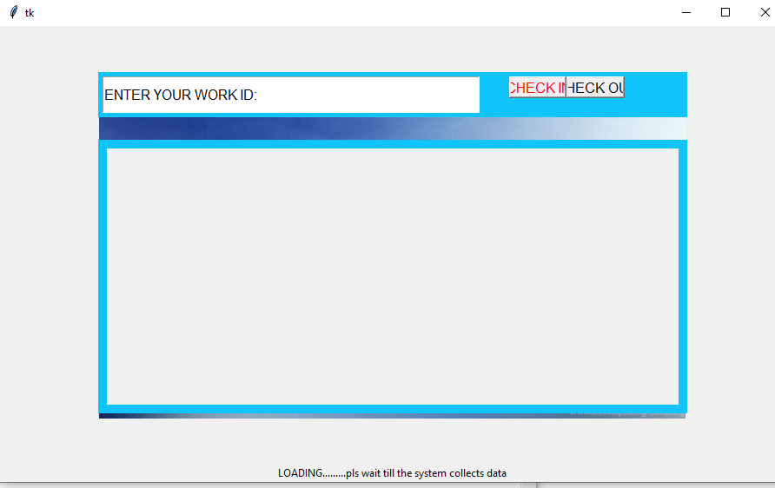

1. DATABASE- using mySQL –

The main calculations and storage utility is provided using mySQL coding. Each data of the employee is made to store in the system and is shown up as soon as the id is entered on the entry provided on the page(made using tkinter).the calculation of work time and the resultant wage is also taken care by this section of coding.

**SOURCE CODE-**

**import mysql.connector**

**from tkinter import \***

**import tkinter as tk**

**from PIL import ImageTk, Image**

**import time**

**mydb=mysql.connector.connect(host="localhost", user="root", password="1234", database="workers")**

**"""**

**#kbg.execute("CREATE DATABASE workers")**

**#CREATING TABLE**

**kbg.execute("CREATE TABLE wagedata(id VARCHAR(255), name VARCHAR(255), wage VARCHAR(255), checkin VARCHAR(255), checkout VARCHAR(255))")**

**mydb.commit()**

**"""**

**kbg=mydb.cursor()**

**#CODING FOR ADDING NEW WORKER**

**"""**

**def check():#ADD NEW WORKER**

**main_data=("INSERT INTO wagedata(id, name) VALUES(%s, %s)")**

**a=input("ENTER NAME")**

**main_data1=(entry.get(), a)**

**kbg.execute(main_data, main_data1)**

**mydb.commit()"""**

**"---------------------------------------------------------------------------------------------------------------------------------------------------------"**

**#TKINTER WINDOW FRAMES AND ETC**

**import tkinter as tk**

**height= 500**

**width=600**

**root=tk.Tk()**

**canvas=tk.Canvas(root, height=height, width=width,bg="blue")**

**canvas.pack()**

**background_image=tk.PhotoImage(file="E:\Downloads\BG.png")**

**background_label=tk.Label(root,image=background_image)**

**background_label.place(relwidth=1,relheight=1)**

**frame=tk.Frame(root,bg="#10C3F8",bd=5)**

**frame.place(relx=0.5,rely=0.1,relwidth=0.75,relheight=0.12,anchor="n")**

**entry=tk.Entry(frame,font=40)**

**entry.place(relwidth=0.65,relheight=1)**

**entry.insert(0,"ENTER YOUR WORK ID:")**

**"-----------------------------------------------------------------------------------------------------------------------------------------------------------"**

**def check_in():#CODING FOR CHECK IN BUTTON**

**global wagetime**

**update="UPDATE wagedata SET checkin= %s WHERE id= %s"#UPDATES THE CHECK IN TIME**

**id_3=(time.asctime(), entry.get() )**

**kbg.execute(update, id_3)**

**id_1="SELECT * FROM wagedata WHERE id=%s"**

**id_2=(entry.get(),)**

**kbg.execute(id_1, id_2)**

**result=kbg.fetchall()**

**for i in result:**

**label=tk.Label(lower_frame, text="ID:"+str(i[0]), height=2, width=125, font=("Times", 12, "bold italic"), anchor='center', borderwidth=2,relief="solid")**

**label.grid(row=2, column=0)**

**label2=tk.Label(lower_frame, bg="#10C3F8")**

**label2.grid(row=3, column=0)**

**label3=tk.Label(lower_frame, text="NAME:"+i[1], height=2, width=125, font=("Times", 12, "bold italic"), anchor='center', borderwidth=2, relief="solid")**

**label3.grid(row=4, column=0)**

**label2=tk.Label(lower_frame, bg="#10C3F8")**

**label2.grid(row=5, column=0)**

**label3=tk.Label(lower_frame, text="CHECK IN TIME:"+i[3], height=2, width=125, font=("Times", 12, "bold italic"), anchor='center', borderwidth=2, relief="solid")**

**label3.grid(row=6, column=0)**

**mydb.commit()**

**wagetime=time.time() #NOTES DOWN THE DECIMAL TIME VALUE**

**"#---------------------------------------------------------------------------------------------------------------------------------------------------------"**

**def check_out():#CODING FOR CHECK OUT BUTTON**

**global wagetime2**

**update="UPDATE wagedata SET checkout= %s WHERE id= %s"#UPDATES THE TIMNE AT CHECKOUT**

**id_4=(time.asctime(), entry.get() )**

**kbg.execute(update, id_4)**

**id_5="SELECT * FROM wagedata WHERE id=%s"**

**id_6=(entry.get(),)**

**kbg.execute(id_5, id_6)**

**result=kbg.fetchall()**

**for j in result:**

**label=tk.Label(lower_frame, text="ID:"+str(j[0]), height=2, width=125, font=("Times", 12, "bold italic"), anchor='center', borderwidth=2,relief="solid")**

**label.grid(row=2, column=0)**

**label2=tk.Label(lower_frame, bg="#10C3F8")**

**label2.grid(row=3, column=0)**

**label3=tk.Label(lower_frame, text="NAME:"+j[1], height=2, width=125, font=("Times", 12, "bold italic"), anchor='center', borderwidth=2, relief="solid")**

**label3.grid(row=4, column=0)**

**label4=tk.Label(lower_frame, bg="#10C3F8")**

**label4.grid(row=5, column=0)**

**label5=tk.Label(lower_frame, text="CHECK IN TIME:"+j[3], height=2, width=125, font=("Times", 12, "bold italic"), anchor='center', borderwidth=2, relief="solid")**

**label5.grid(row=6, column=0)**

**label6=tk.Label(lower_frame, bg="#10C3F8")**

**label6.grid(row=7, column=0)**

**label7=tk.Label(lower_frame, text="CHECK OUT TIME:"+j[4], height=2, width=125, font=("Times", 12, "bold italic"), anchor='center', borderwidth=2, relief="solid")**

**label7.grid(row=8, column=0)**

**button=tk.Button(frame,text="CHECK IN",fg="red",font=35,command=check_in, state=DISABLED)**

**button.place(relx=0.7,relwidth=0.1,relheight=0.6)**

**wagetime2=time.time()**

**mydb.commit()**

**"#---------------------------------------------------------------------------------------------------------------------------------------------------------"**

**def wage_1():#CODING FOR CALCULATING AND DISPLAYING THE MONEY EARNED**

**timer=int(wagetime2-wagetime)**

**wages=timer*1000 #UPDATE THE WAGE PER HOUR**

**update="UPDATE wagedata SET wage= %s WHERE id= %s"**

**id_7=(wages, entry.get() )**

**kbg.execute(update, id_7)**

**id_8="SELECT * FROM wagedata WHERE id=%s"**

**id_9=(entry.get(),)**

**kbg.execute(id_8, id_9)**

**result=kbg.fetchall()**

**for k in result:**

**label8=tk.Label(lower_frame, bg="#10C3F8")**

**label8.grid(row=9, column=0)**

**label9=tk.Label(lower_frame, text="TODAYS EARNINGS:"+k[2], height=2, width=125, font=("Times", 12, "bold italic"), anchor='center', borderwidth=2, relief="solid")**

**label9.grid(row=10, column=0)**

**mydb.commit()**

**def clear():#CODING FOR CLEAR BUTTON**

**button=tk.Button(frame,text="CHECK IN",fg="red",font=35,command=check_in, state=NORMAL)**

**button.place(relx=0.7,relwidth=0.1,relheight=0.6)**

**for widget in lower_frame.winfo_children():**

**widget.destroy()**

**#ALL THE BUTTONS LIST**

**"#---------------------------------------------------------------------------------------------------------------------------------------------------------"**

**button=tk.Button(frame,text="CHECK IN",fg="red",font=40,command=check_in)**

**button.place(relx=0.7,relwidth=0.1,relheight=0.6)**

**"#---------------------------------------------------------------------------------------------------------------------------------------------------------"**

**button2=tk.Button(frame,text="CHECK OUT",font=40, command=check_out)**

**button2.place(relx=0.8,relwidth=0.1,relheight=0.6)**

**"#---------------------------------------------------------------------------------------------------------------------------------------------------------"**

**button3=tk.Button(frame,text="WAGES",font=40, command=wage_1)**

**button3.place(relx=0.9,relwidth=0.1,relheight=0.6)**

**"#---------------------------------------------------------------------------------------------------------------------------------------------------------"**

**button4=tk.Button(frame,text="CLEAR",font=40, command=clear, height=1,)**

**button4.place(relx=0.8, rely=0.6, relwidth=0.1)**

**"#---------------------------------------------------------------------------------------------------------------------------------------------------------"**

**lower_frame=tk.Frame(root,bg="#10C3F8",bd=10)**

**lower_frame.place(relx=0.5,rely=0.25,relwidth=0.75,relheight=0.6,anchor="n")**

**root.mainloop()**

***OUTPUT:***

1. Interface asking user to enter id.

1. Enters id and clicks on check in- program shows check in time.

1. Clicks on check out after work. Program displays check out time.

1. Wages button results in an output showing the employees current earning .

***BIBLIOGRAPHY:***

*SPECIAL THANKS TO-*

1. *CODEMY YT – helped in learning basics of tkinter and SQL.*
2. *KEITH GALLI – tkinter GUI basics*